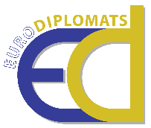

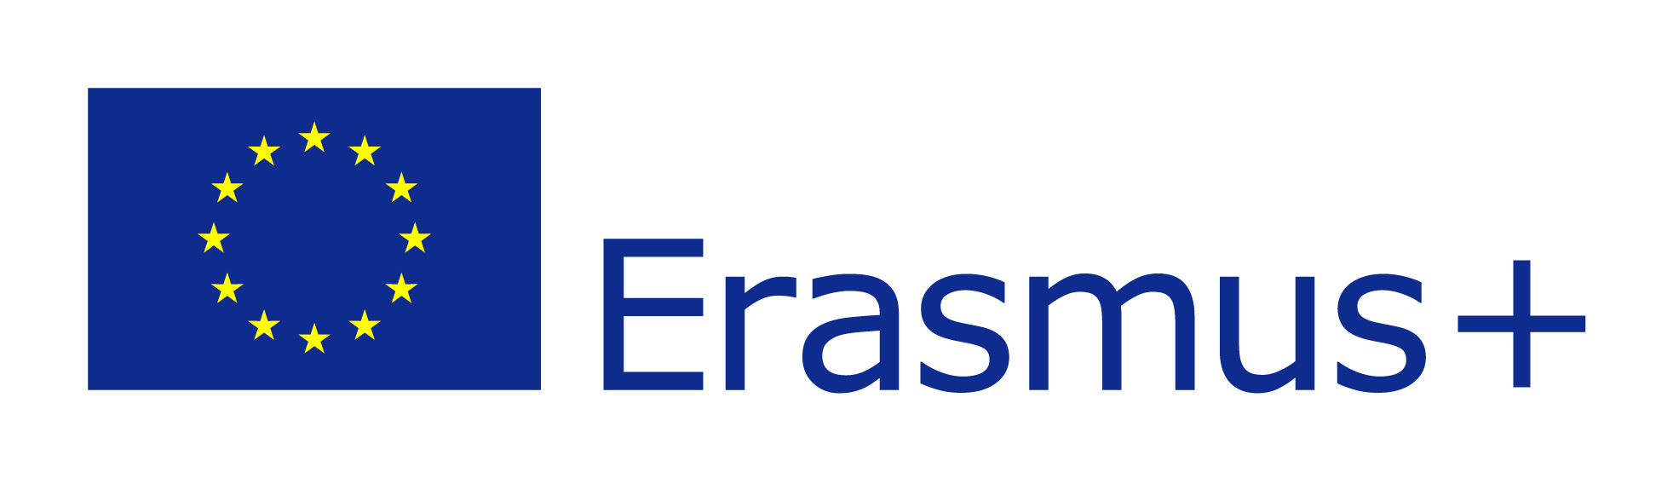

**The EURODIPLOMATS Plan for Supporting Policy Reform**

***“Εmpowering children to act as cultural***

***diplomats for a robust and resilient Europe”***

***EURODIPLOMATS***

*Project reference:* ***2020-1-CY01-KA227-SCH-082681***

**Executive summary and Objectives**

EURODIPLOMATS scales up good practices on the intersection of cultural diplomacy and education and on promoting common values, initiated in particular at local level, but also on a wider scale involving more countries and transferring it to the primary schools, enriching it by adding a specific focus on collaborative art-making pedagogy, collaborative storytelling and poetry pedagogy, and digital culture pedagogy. This project aims to foster a collaborative and creative pedagogical methodology based on the strategy of cultural diplomacy designed to develop transversal skills related to interculturalism, sustainability, social justice, and resilience that make Europe robust and strong to meet current and future threats. The EURODIPLOMATS Methodological Tool developed, addressed to primary education, has already proved to be successfully when tested in the 4 European countries participating in the project (namely, Cyprus, Greece, Malta, and Spain). Using the cultural diplomacy approach, EURODIPLOMATS gives the students and the teachers an educative tool consisting of a fully-developed methodology, creative and provoking lesson plans, and other workshops, activities and resources, that may be used by teachers and students as critical recourses to understand better the world where they live and to interpret their society in order to reinforce shared European values that make Europe robust and resilient. The long-term impact of the project is mainly linked to the implementation of a new curriculum on cultural diplomacy education and the EURODIPLOMATS model.

In this ‘Plan for Supporting Policy Reform’ document, we aim to draw suggestions and recommendations for the successful use of the EURODIPLOMATS methodology, resources, activities and tools, as described in the EURODIPLOMATS methodological tool, resources and activities, and teachers’ and children’s handbooks. Although the use of the Tool and Resources developed is highly effective for teaching and learning, policy conditions should be set out to support its successful implementation. The successful implementation of the EURODIPLOMATS Methodological Tool and the EURODIPLOMATS Resources and Activities relies on overcoming enduring educational challenges: teaching-time constraints that leave little room for creative activities that support critical thinking; constraints to teacher-student relationships, traditional learning environments that are resistant to change; curriculum constraints; cultural, socio-economic, ethnocentrism and stereotypes permeating educational policies. To overcome the aforementioned barriers, actions should be taken at system, institutional, and individual levels. Below, we present some key recommendations for such actions. The immediate addresses of these recommendations are authorities, institutions and policymakers at both the European Union (EU) and national levels, school bodies, students’ and/or parents’ associations, teachers’ associations, and the civil society. ***Figure 1*** diagrammatically portrays our policy reform recommendations.

**Figure 1:** Suggestions for Policy Reform

**Recommendations for Policy Reform**

**SYSTEMIC LEVEL**

**Integrate cultural diplomacy in the official curriculum.**

**Aim:** Contribute to the diffusion of culturally pluralistic, environmentally sustaining, and intercultural, interfaith and peace values in the school curricula, policies and life through cultural, and cultural diplomacy initiatives.

**Actions**

• Introduce shared European principles and cultural values underpinning a robust and resilient Europe at the curricula of all students, as early as preschool school. This foundation of pluralistic values and competences can be further built in primary and secondary school.

• Introduce ‘Cultural Diplomacy in Education’ as a specific subject in school programmes and other curriculum subjects such as Environmental Education, Geography, Languages, Literature, etc. In these subjects, teaching and learning via cultural diplomacy should be presented and promoted as a “social skill”.

• Introduce ‘Cultural Diplomacy in Education’ as a part of non-formal education (i.e. extracurricular activities, school clubs, school excursions, etc.).

**Relevant stakeholders**

Decision-makers at EU and national level – European Commission (EC), ministries of education, regional inspectorates, municipalities and school staff, school administrations.

**Facilitate the development of a network of teachers working for cultural diplomacy in education.**

**Aim:** Build strong and productive national and international networks of teachers that would operate as a community of learning and practice.

**Actions**

• Organise seminars and/or roundtables for Cultural Diplomacy and/or Active Citizenship teachers, where experiences and recommendations are shared and discussed. In these activities, teachers will share common concerns and experience.

• Organise webinars or create platforms and online forums for discussion and exchange of experience and knowledge.

• Create networks of schools, implementing non-formal extracurricular programmes of Cultural Diploamcy in Education to increase opportunities for shared activities and grassroots initiatives.

**Relevant stakeholders**

School staff, school administrations, local, national, and international parents’, teachers’ and students’ associations, civil society organisations.

**INSTITUTIONAL LEVEL**

**Design and create optimal teaching and learning environments.**

**Aim:** Design and create optimal learning environments to make students more receptive, but also more agentic, in cultural diplomacy initiatives. In these environments, social and emotional competencies are practised, an enhanced understanding and appreciation of European collaboration is developed, student voice is honoured and perspective-taking is encouraged.

**Actions**

• Build a democratic environment in the school in order to provide students coming from various socio-cultural groups with the opportunity to influence the school culture and curriculum.

• Build school-family-community connections and partnerships as a venue for cultural dialogue, and where cultural diplomacy initiatives may take place.

• Build a democratic classroom environment that will allow the better practising of cultural diplomacy initiatives that may be promoted by classroom discussions about European values that make Europe robust and resilient to meet current and future threats.

• Use the EURODIPLOMATS tools to design classes in ways that allow students to engage in learning-by-doing activities in collaborative art-making pedagogy, collaborative storytelling and poetry pedagogy, and digital culture pedagogy.

• Design physical, digital, and social environments that support learning for all and thus, all students’ engagement in discussions and activities about cultural diplomacy in education for a robust Europe.

• Design and implement “outside-the-classroom” activities to relate cultural diplomacy to real-life experiences.

• Encourage discussion on cultural diplomacy issues and the coming together of students of diverse religious and ethnic backgrounds to work together for a robust and resilient Europe through extracurricular societies and activities.

**Relevant stakeholders**

Decision-makers at EU and national level – EC, ministries of education, regional inspectorates, municipalities, school staff, school administrations, local, national and international parents’, teachers’ and students’ associations, civil society organisations.

**Tailor teaching approaches to the needs of the EURODIPLOMATS Methodology.**

**Aim:** Plan and implement changes in teaching approaches and practices so that lessons could be tailored to the needs of the EURODIPLOMATS Methodology in order to increase students’ participation and positively influence their perceptions of cultural diplomacy.

**Actions**

• Train teaching staff to use the EURODIPLOMATS Methodological Tool and specifically the use of tools such as collaborative art-making, collaborative storytelling, and digital culture pedagogy to cultivate students’ skills as cultural diplomats.

• Design and implement evaluations of the students’ performances.

• Train students and offer them pedagogical support to engage in the EURODIPLOMATS Methodology and the use of the EURODIPLOMATS Resources and Activities in order to enhance their openness.

• Train community members and parents to become involved in teaching and learning approaches based on Cultural Diplomacy and to secure their involvement in all steps of the EURODIPLOMATS methodology.

**Relevant stakeholders**

Regional inspectorates, school staff, school administrations, local, national and international parents’, teachers’ and students’ associations, civil society organisations.

**INDIVIDUAL LEVEL**

**Support dialogue on cultural heritage, interculturalism, sustainability, European shared values, and European resilience.**

**Aim:** Eradicate stereotypes and discrimination, and role-model peace, social justice, sustainability, environmental protection, and inclusion and promote these values through the individual efforts of various stakeholders.

**Actions**

• Enhance a vision for cultural diplomacy in education and collaborate with schools to share this vision and integrate it in their policies and lessons.

• Support collaborations between schools and NGOs working in the field of cultural diplomacy to help promote intercultural values and a dialogue on peace, sustainability, and resilience in Europe.

• Reinforce teacher training and teacher networking on issues related to cultural diplomacy in education.

**Relevant stakeholders**

School staff, school administrations, local, national and international parents’, teachers’ and students’ associations, civil society organisations.

Top of Form

**Enhance teacher-student relations.**

**Aim:** The power-relations and the nature of relationship between teachers and students are crucial to prosocial activities’ potential to foster changes of values and perceptions. Improving this relationship will contribute vastly to the prosocial principles’ potential to influence and shape students perspectives and value systems.

**Actions**

• Facilitate positive communication between teachers and students by creating ‘safe’ environments for students to openly discuss their thoughts, views and ideas about cultural diplomacy and creating a robust and resilient Europe.

• Develop and implement a repertoire of trust-building activities to work on the goals of promoting trust, eliminating conflict, and building a high degree of closeness and support.

• Give students the opportunity to meaningfully and actively engage in important decisions with regards to topics for discussion and pertinent activities to promote cultural diplomacy.

• Use socio-emotional teaching strategies to enhance emotional literacy in students and to help them develop empathy, identify feelings in self and others, and develop problem solving skills.

•Allow students to work as equals to adults in actively setting goals, designing and leading activities, and making decisions with regards to implementing cultural diplomacy in education, in general, and specific lessons, in particular.

• Empower students to take the initiative in extracurricular activities of cultural diplomacy so as to contribute in building a robust and resilient Europe able to meet current and future threats.

**Relevant stakeholders**

School staff, school administrations, local, national and international parents’, teachers’ and students’ associations.